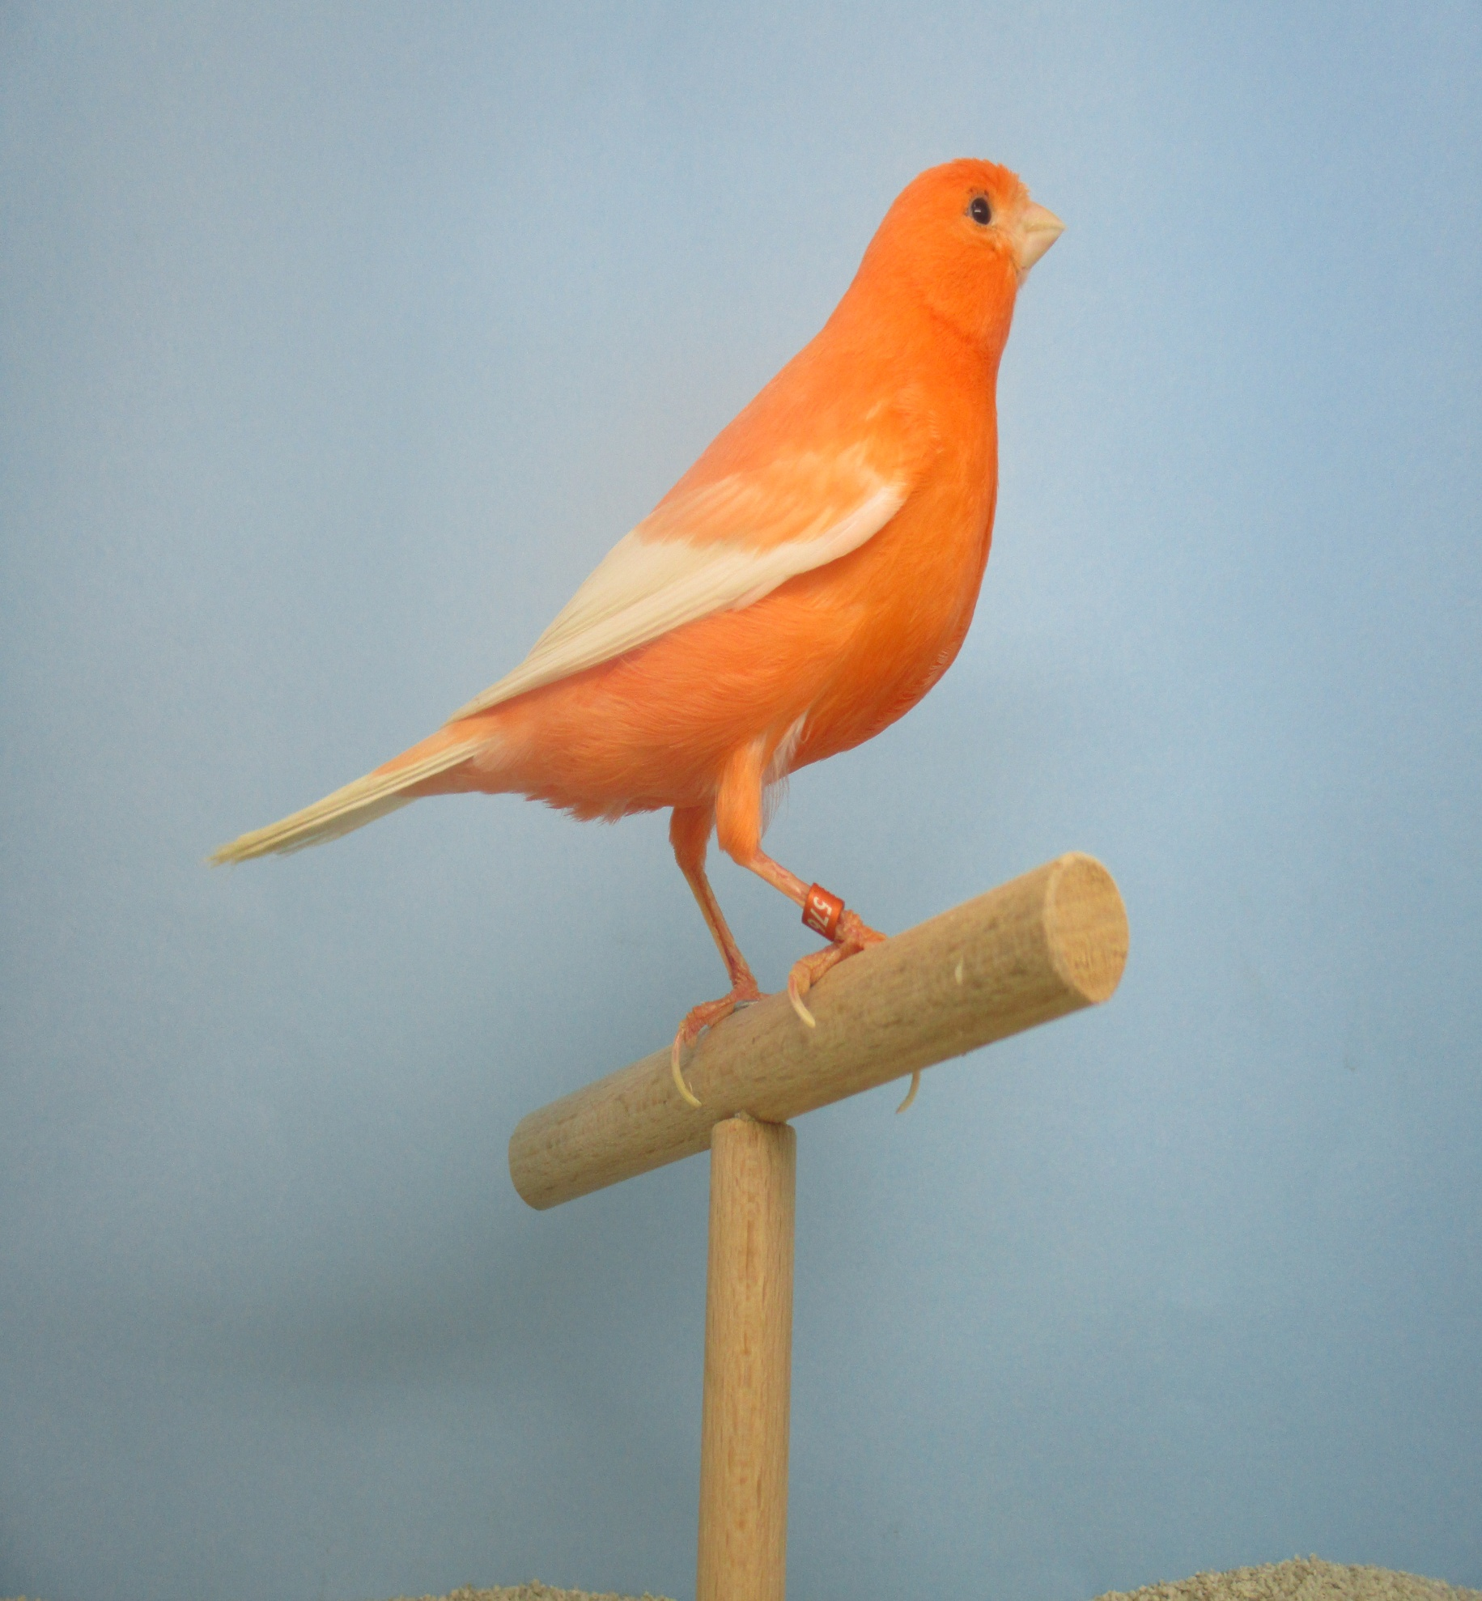
AVIARIO;

Juan francisco BURGOS 2017 C.N. 5A-18 622599876

